INTERNSHIP TECHNICAL REPORT
Intern: Khuzaima Ahmed
Degree Program: BS Electronics (Final Year), Quaid-i-Azam University (QAU), Islamabad
Domain: Printed Circuit Board (PCB) Design & Engineerings
Mode: Remote Internship
Organization: National Institute of Electronics (NIE)

Executive Summary
This technical report documents the engineering principles, physical parameters, and fabrication specifications studied during the remote internship program at the National Institute of Electronics (NIE). Completed alongside final-year electronics coursework at Quaid-i-Azam University, this training focused on core PCB architecture, laminate properties, component packaging standards, layer transition mechanics, and silk-screening conventions required for reliable hardware production.

1. Introduction to PCB Architecture
A Printed Circuit Board (PCB) provides both physical structure and electrical connectivity for electronic systems, replacing hand-wired circuits with copper conductors bonded onto an insulating substrate.
Board structures are categorized by their physical layer configurations:
Single-Sided PCBs: Feature a single conductive copper layer on one side of the dielectric substrate. Components mount on top, with traces routed underneath. Used primarily in low-cost, low-density applications.
Double-Sided PCBs: Contain copper conductive layers on both top and bottom sides. Plated Through-Holes (PTH) enable signal transitions between layers, significantly increasing overall routing density.
Multi-Layer PCBs: Consist of three or more copper layers separated by dielectric materials (core and prepreg). Internal layers are dedicated to Ground (GND) and Power (VCC) planes, which reduces electromagnetic interference (EMI) and maintains signal integrity across high-speed signals.

2. Materials and Fabrication Specifications
Selecting appropriate substrate materials and layer properties is critical for electrical performance, mechanical durability, and thermal management.

Parameter / Material | Technical Specification | Engineering Impact
FR-4 Substrate | Glass-reinforced epoxy matrix (Tg ≈ 130°C - 170°C) | Standard structural substrate offering electrical insulation and structural rigidity.
High-Frequency Laminates | Rogers PTFE / Ceramic composites | Low dielectric loss materials specified for microwave and high-speed RF boards.
Dielectric Constant (εr) | 4.2 - 4.8 (Standard FR-4 at 1 GHz) | Governs trace impedance (Z0), propagation delay, and inter-layer capacitance.
Board Thickness | Standard 1.6 mm (~0.062 in); range: 0.4 mm to 3.2 mm | Defines overall board rigidity and housing enclosure compatibility.
Copper Weight | 1 oz/ft² (≈ 35 µm) standard; 2 oz/ft² (≈ 70 µm) high-power | Sets maximum current-carrying capacity (I) and thermal dissipation limits.

3. Electronic Component Mounting Technologies
Components are integrated onto PCBs using two primary mounting formats, selected based on physical stress, power handling, and space requirements.

Through-Hole Technology (THT)
Mechanics: Component leads pass through drilled, copper-plated holes and solder to pads on the reverse side.
Advantages: Superior mechanical bond strength; ideal for heavy components, power connectors, switches, and high-stress environments.
Disadvantages: Occupies physical space across all layers due to full-depth drill holes, reducing available routing channels.

Surface Mount Technology (SMT)
Mechanics: Surface Mount Devices (SMDs) sit directly on copper pads on outer surface layers and reflow-solder in place.
Package Standards: Passive devices utilize imperial footprint codes (1206, 0805, 0603, 0402). Active IC packages include SOIC, QFP, and high-density BGA (Ball Grid Array).
Advantages: High component density, smaller board footprint, reduced parasitic inductance, and suitability for high-speed automated pick-and-place assembly.

4. Layer Interconnection: Via Classifications
Vias are copper-plated drilled cylinders that establish electrical connections between distinct layers of a multi-layer board stackup.
Through-Hole Via: Passes completely from the top layer to the bottom layer. It is the most standard and cost-effective via type.
Blind Via: Connects an outer surface layer (Top or Bottom) to an internal layer without penetrating through the entire board thickness.
Buried Via: Connects internal layers exclusively, completely hidden inside the dielectric stackup with no exposure to outer surfaces.
Microvia: Laser-drilled small vias (< 150 µm diameter) spanning a single layer step, primarily used in High-Density Interconnect (HDI) boards.

5. Silkscreen Identification Layer
The silkscreen layer consists of non-conductive ink printed onto the board surface to provide guidance during manual assembly, automated inspection, testing, and debugging.
Reference Designators (RefDes): Standardized alphanumeric codes matching schematic identifiers (e.g., R1, R2 for resistors; C1 for capacitors; U1 for ICs; D1 for diodes).
Component Outlines & Orientation: Physical boundary markings showing placement limits, alongside polarity markers like Pin 1 dots, chamfer marks, diode cathode bands, and capacitor positive (+) symbols.
Header & Pinout Labels: Text annotations adjacent to pin headers defining signal functions (e.g., VCC, GND, TX, RX, SDA, SCL).
Test Points: Markings pinpointing exact nodes for multimeter probes, oscilloscope measurements, and quality control (e.g., TP_3V3, TP_GND).

6. Design Project: Custom 4-Layer STM32 System Board
To synthesize the theoretical design principles, substrate parameters, and routing geometries covered during the internship, a 4-layer custom hardware design project was executed utilizing an STM32 microcontroller unit (MCU) core architecture.
Schematic Diagram:
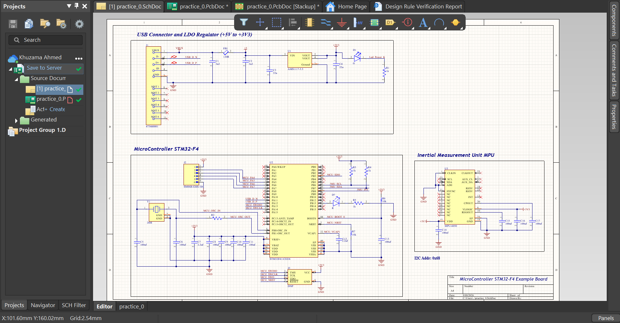

Layer Stackup & Dielectric Parameters
The board structure follows a symmetrical 1.6 mm total thickness profile with dual internal ground planes for maximum noise suppression and EMI control:
Outer Signal Layers (Top & Bottom): Standard 1 oz copper weight (0.035 mm) for robust current-carrying capacity, high-speed MCU routing, and localized power distribution (+3.3V, +5V, VDDA).
Internal Plane Layers (Int1 & Int2): Dedicated internal ground planes constructed with 0.5 oz copper weight (0.0175 mm), creating continuous, low-impedance reference return paths directly beneath both outer signal layers.
Dielectric Substrates: Prepreg dielectric layers (PP-017, 0.2 mm, Dk = 4.4, Df = 0.02) separate outer signal traces from internal planes, while a central core (Core-039, 1.065 mm, Dk = 4.6, Df = 0.02) provides physical rigidity.
Surface Masking & Finish: Lead-tin (PbSn) surface finish (0.02 mm) with liquid photoimageable solder mask (0.0254 mm, Dk = 4.0) for pad preservation and oxidation protection.
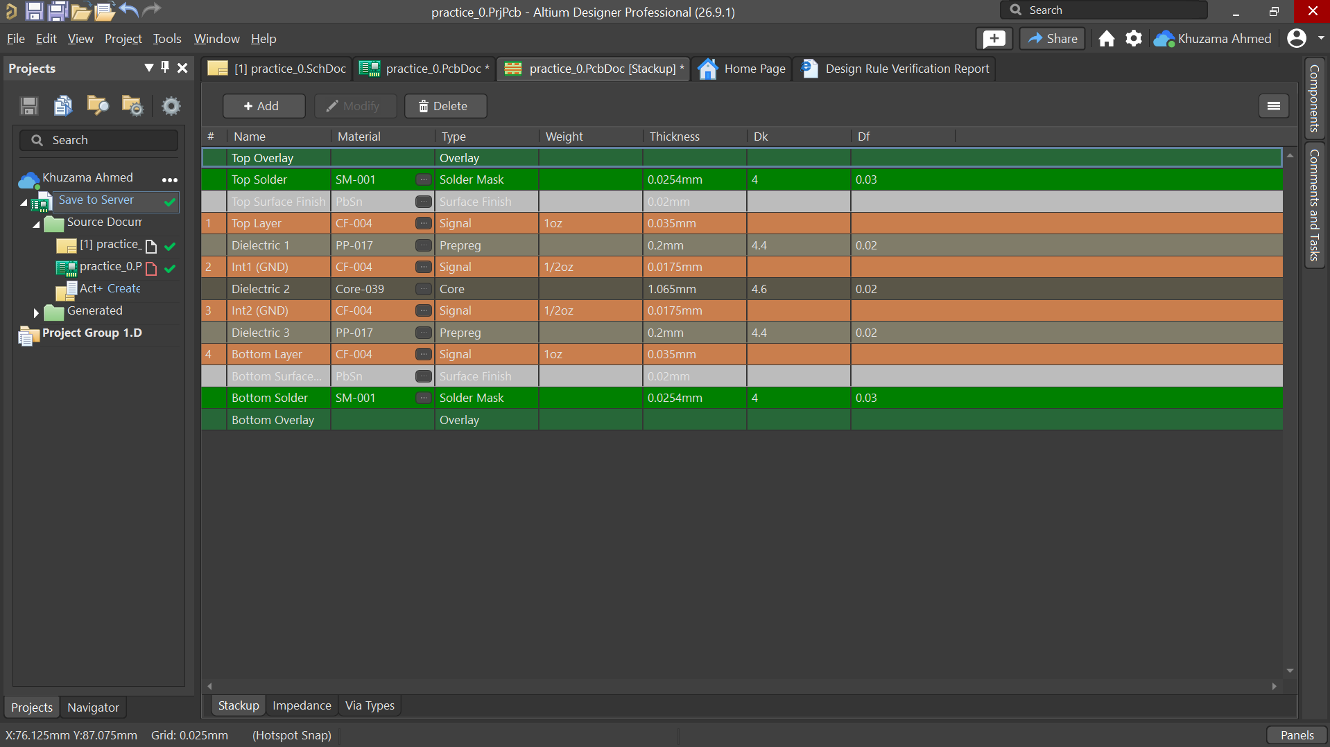
Routing Strategy & Grounding Architecture
Dual Ground Plane Shielding: Int1 (GND) and Int2 (GND) shield the central core, isolating top and bottom routing paths while maintaining consistent characteristic trace impedance.
Decoupling Optimization: Surface mount decoupling capacitors (100 nF / 10 µF) are situated adjacent to MCU VDD/VSS pin pairs with short direct vias to Int1/Int2 to minimize loop inductance.
Ground Stitching: Stitching vias connect Int1 and Int2 along board edges and signal transition points to ensure potential equalization across reference planes.
PCB Footprints:
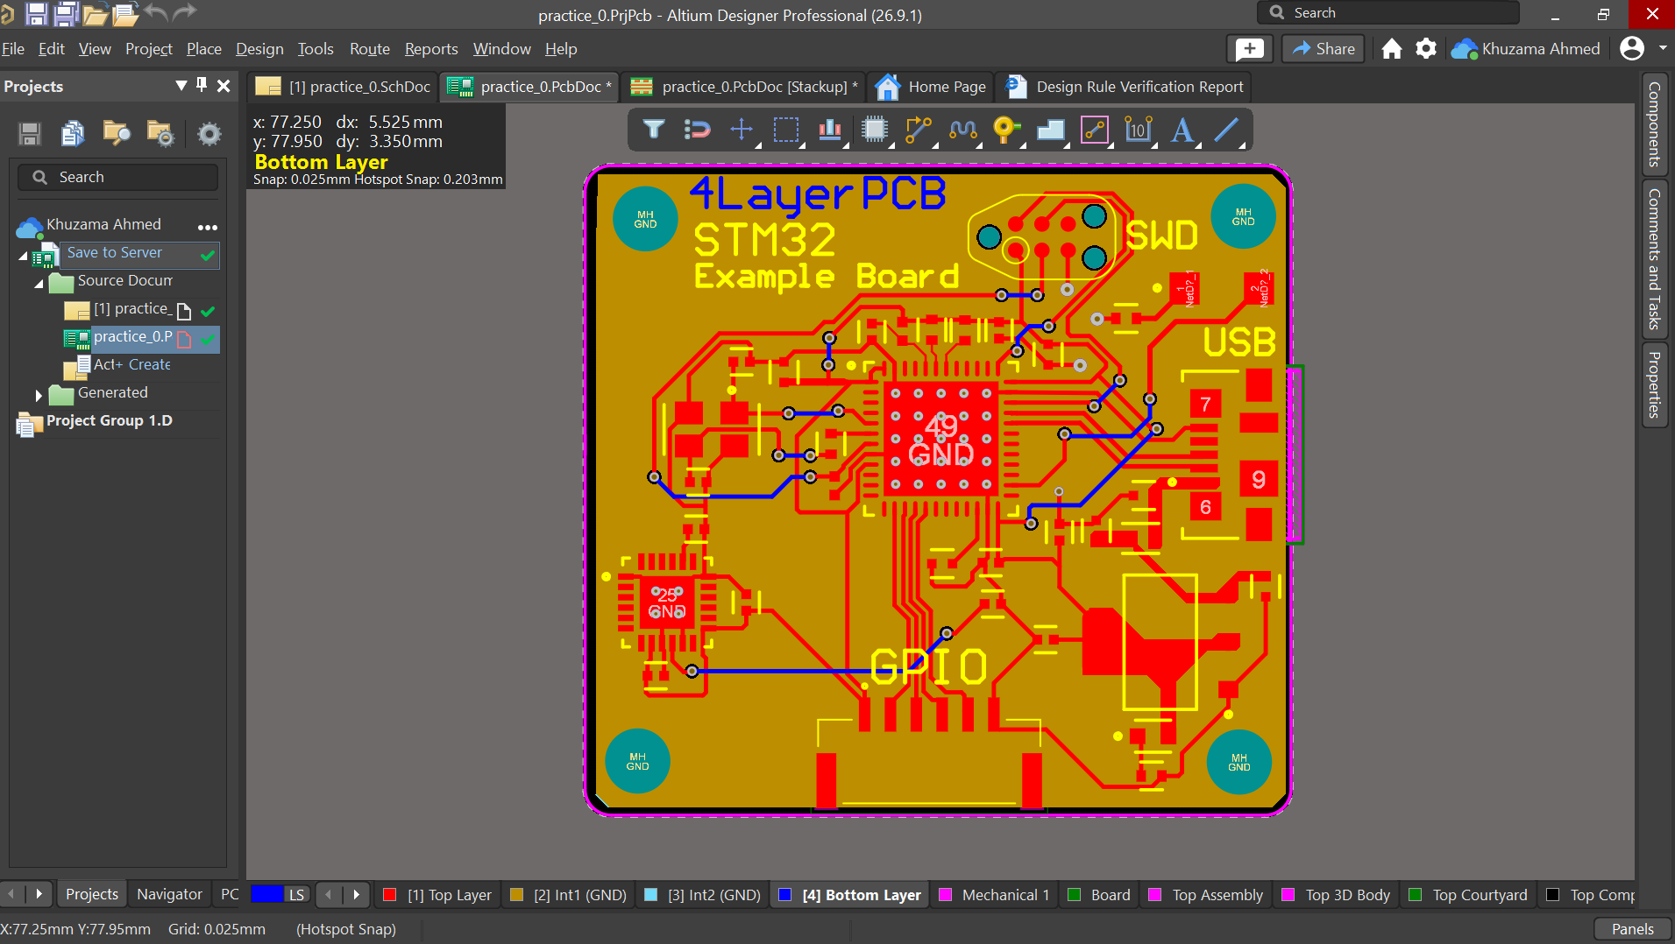

3D Model:
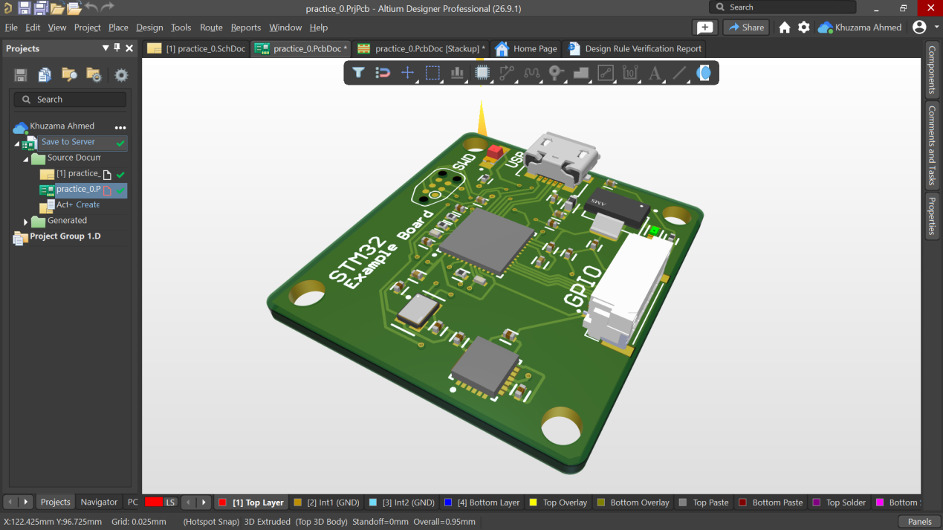

Verification & Zero-DRC Compliance
Comprehensive Design Rule Checks (DRC) were conducted against physical manufacturing thresholds, including 6 mil minimum trace/space clearances, annular ring parameters, drill-to-copper distances, and solder mask expansion limits. The layout achieved Zero DRC Errors, confirming complete manufacturability (Design for Manufacturing - DFM). 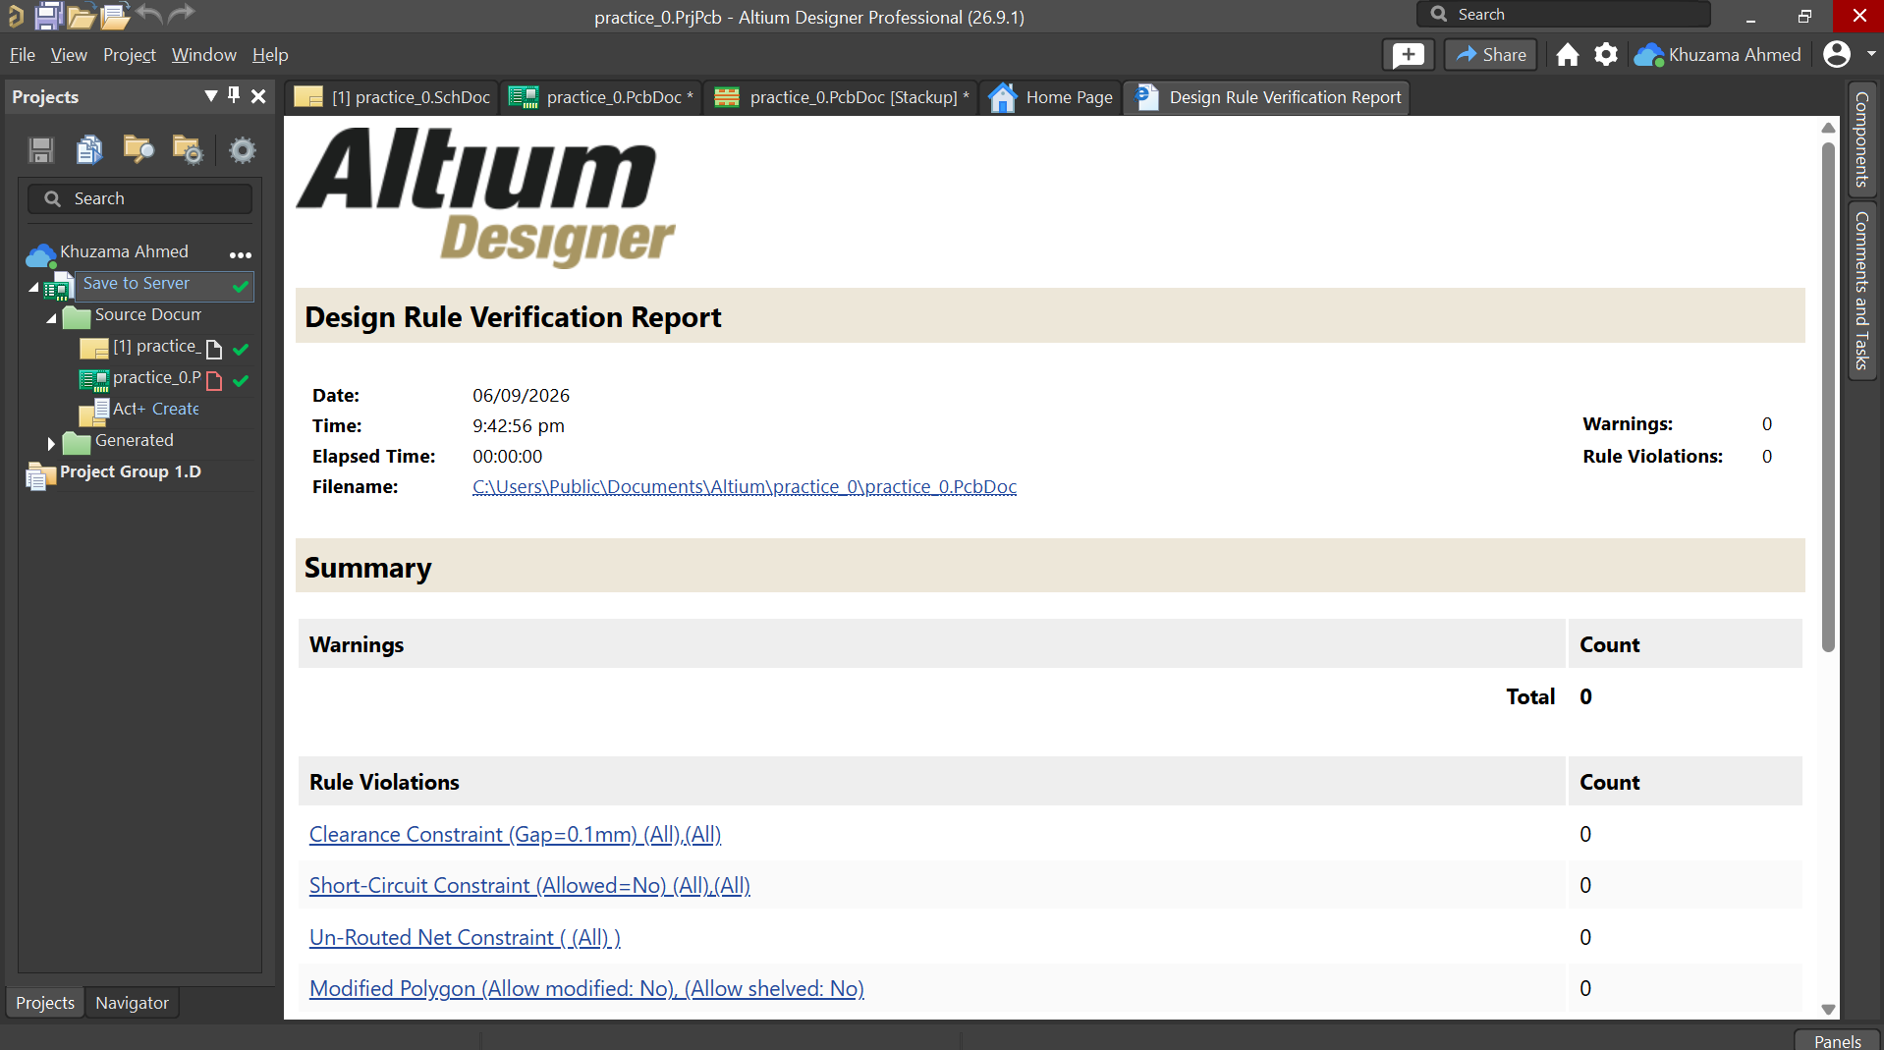

Conclusion
The remote internship with the National Institute of Electronics (NIE) enhanced my academic foundation in electronics at Quaid-i-Azam University. It provided a clear understanding of physical board structures, substrate properties, footprint geometries, and layer interconnection mechanics necessary for hardware design and fabrication.

